PYTHON PROJECT
Title: Cyber Security Password Analyzer and Message Tool using Python
Name: Rohan S
Register No: 411625243043
Department: B.Tech Artificial Intelligence and Data Science
Batch No: 5
Subject: Python

AIM
To design and develop a Cyber Security Password Analyzer and Message Tool using Python that performs password strength checking, message encryption, decryption, text analysis, and pattern generation while demonstrating various Python programming concepts such as operators, strings, lists, recursion, functions, and decision making.

OBJECTIVE
• To understand the fundamental concepts of Python programming.
• To implement string manipulation techniques.
• To apply recursion for reversing a message.
• To use lists for storing and processing characters.
• To implement decision making using conditional statements.
• To create pattern printing using loops.
• To develop an interactive console-based cybersecurity utility.

PROCEDURE
- Installed Python software and opened the Python IDLE development environment.
- Created a new Python file named cyber_security_tool.py.
- Defined a recursive function named reverse_string() to reverse a message using recursion.
- Created an encrypt_message() function to encrypt messages by shifting ASCII values of characters.
- Created a decrypt_message() function to convert encrypted text back to its original form.
- Developed a password_strength() function to analyze password security.
- Used operators and conditional statements to check whether the password contains:
• Digits
• Uppercase letters
• Lowercase letters
• Special characters
- Stored password characters in a list using the list() function.
- Calculated a security score based on the presence of different character types.
- Used if-elif-else decision making statements to classify passwords as:
• Strong
• Medium
• Weak
- Created a text analysis function to count vowels and consonants in a message.
- Used a list of vowels to compare characters in the message.
- Implemented loops to process each character in the text.
- Created a security_pattern() function to generate star patterns based on the length of input.
- Displayed a menu-driven interface using print statements.
- Allowed the user to choose options such as:
• Check password strength
• Encrypt message
• Decrypt message
• Reverse message using recursion
• Analyze text
- Accepted the user’s choice using the input() function.
- Executed the selected operation using if-elif-else conditions.
- Displayed results and generated a pattern based on input length.
- Repeated testing to ensure proper working of all modules including:
• Encryption and decryption
• Recursive string reversal
• Password strength checking
• Pattern generation
- Successfully executed the program in the Python IDLE environment.

PYTHON CODE
# Cyber Security Password Analyzer & Message Tool
def reverse_string(text):
if len(text) == 0:
return text
return reverse_string(text[1:]) + text[0]
def encrypt_message(message):
encrypted = ""
for ch in message:
encrypted += chr(ord(ch) + 2)
return encrypted
def decrypt_message(message):
decrypted = ""
for ch in message:
decrypted += chr(ord(ch) - 2)
return decrypted
def password_strength(password):
score = 0
if any(c.isdigit() for c in password):
score += 1
if any(c.isupper() for c in password):
score += 1
if any(c.islower() for c in password):
score += 1
if any(c in "!@#$%^&*" for c in password):
score += 1
if score >= 3 and len(password) >= 8:
return "Strong Password"
elif score >= 2:
return "Medium Password"
else:
return "Weak Password"
def analyze_text(text):
vowels = ["a","e","i","o","u"]
vowel_count = 0
consonant_count = 0
for ch in text.lower():
if ch.isalpha():
if ch in vowels:
vowel_count += 1
else:
consonant_count += 1
print("\nText Analysis")
print("Vowels:", vowel_count)
print("Consonants:", consonant_count)
def security_pattern(n):
print("\nSecurity Pattern\n")
for i in range(1, n+1):
print("* " * i)
for i in range(n-1,0,-1):
print("* " * i)
def main():
while True:
print("\n===== CYBER SECURITY TOOL =====")
print("1. Check Password Strength")
print("2. Encrypt Message")
print("3. Decrypt Message")
print("4. Reverse Message")
print("5. Analyze Text")
print("6. Exit")
choice = int(input("Enter your choice: "))
if choice == 1:
password = input("Enter password: ")
char_list = list(password)
print("\nCharacters stored in list:")
print(char_list)
result = password_strength(password)
print("Password Strength:", result)
security_pattern(len(password))
elif choice == 2:
message = input("Enter message: ")
encrypted = encrypt_message(message)
print("Encrypted Message:", encrypted)
security_pattern(len(message))
elif choice == 3:
message = input("Enter encrypted message: ")
decrypted = decrypt_message(message)
print("Decrypted Message:", decrypted)
security_pattern(len(message))
elif choice == 4:
message = input("Enter message: ")
reversed_msg = reverse_string(message)
print("Reversed Message:", reversed_msg)
security_pattern(len(message))
elif choice == 5:
text = input("Enter text: ")
analyze_text(text)
security_pattern(len(text))
elif choice == 6:
print("Exiting program...")
break
else:
print("Invalid choice")
main()

SAMPLE OUTPUT
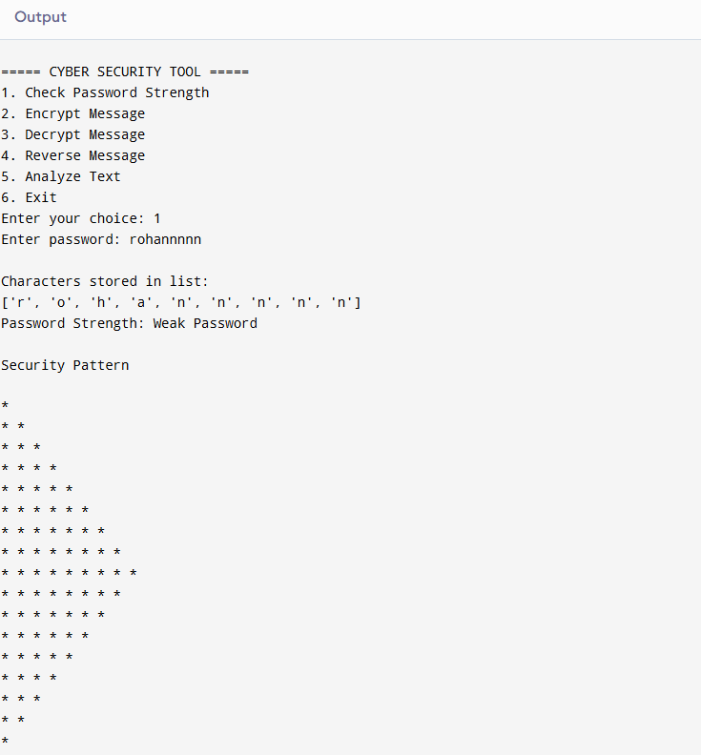
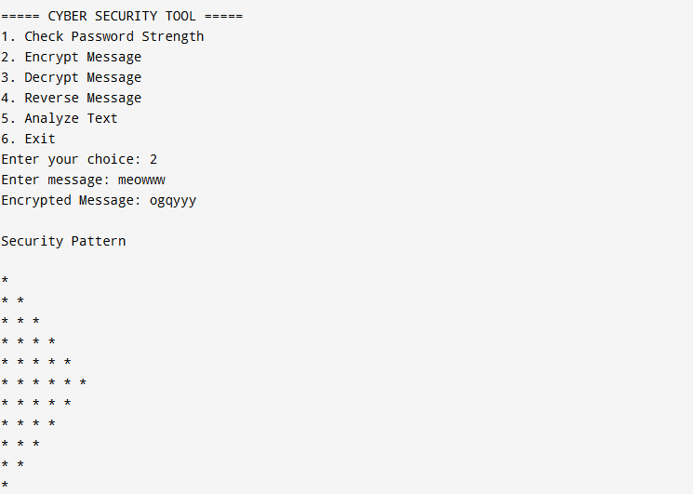
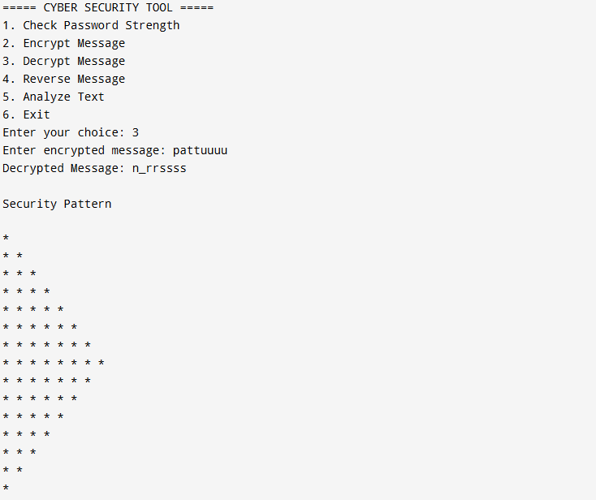

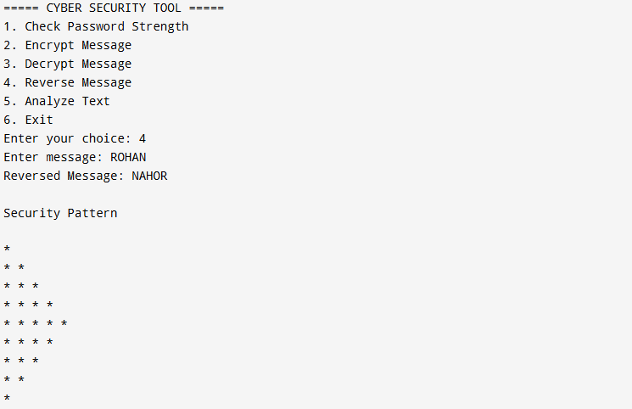
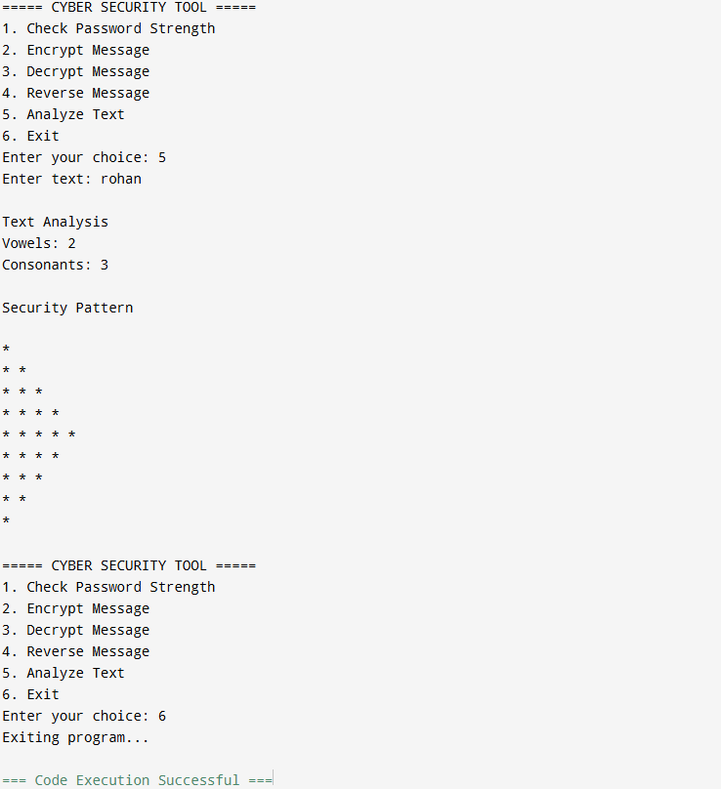

RESULT
The Cyber Security Password Analyzer and Message Tool was successfully developed using Python. The program demonstrated the use of recursion, functions, lists, strings, operators, loops, and decision making to build an interactive cybersecurity utility.

